Project Design Phase
Problem – Solution Fit Template
Date | 12 July 2026
Team ID | Geeta Rani
Project Name | ShopEZ
Maximum Marks | 2 Marks

Problem – Solution Fit Canvas for ShopEZ
The Problem-Solution Fit Canvas was used to analyze the relationship between online shoppers and the solution provided by ShopEZ. It aided in understanding the needs of customers, cart and checkout problems, user behavior, limitations, and existing alternatives. It further showed how ShopEZ can solve these problems through a secure, streamlined system for browsing, cart management, and account access.
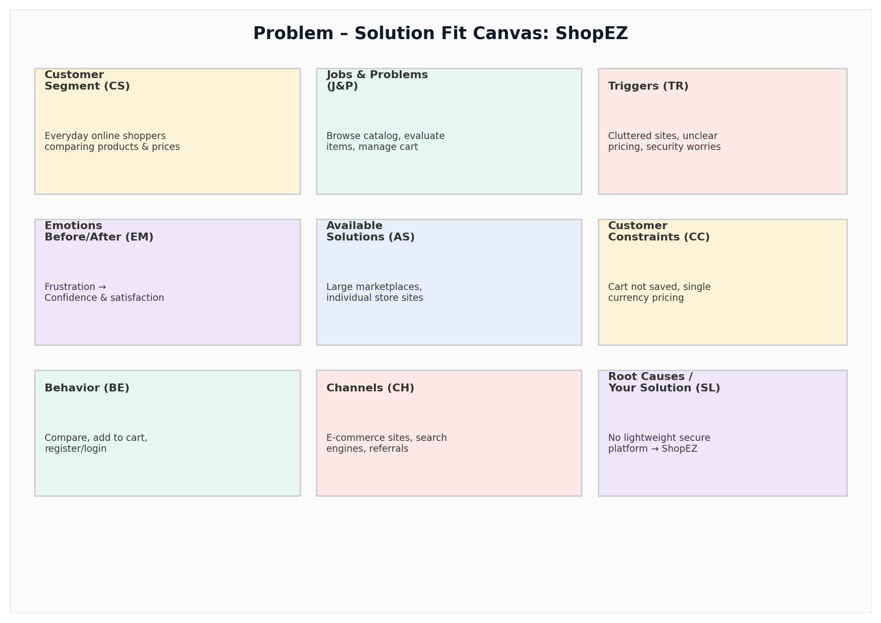

Customer Segment (CS):
The intended customer segment for ShopEZ is everyday online shoppers who want to browse a product catalog, compare prices and ratings, and complete purchases quickly. These customers need an easy way to discover products and manage a cart without switching between multiple platforms.

Jobs-to-be-Done / Problems (J&P):
The key responsibilities are to browse a wide product catalog, evaluate items by price/rating/discount, and manage a shopping cart efficiently. The ShopEZ solution fulfills these requirements through a product listing feature, cart add/update/remove actions, and a multi-currency price display.

Triggers (TR):
Some of the primary factors that compel users to look for a better solution are difficulty comparing products across sites, time consumed navigating cluttered listings, and uncertainty around account security. In response, ShopEZ offers a single, clean platform for product discovery and cart management.

Emotions Before / After (EM):
Before using ShopEZ, shoppers usually feel frustration and hesitation from cluttered listings and unclear pricing. After using the platform, shoppers feel confident and satisfied because they can browse, compare, and add products to their cart quickly and securely.

Available Solutions (AS):
These include existing large marketplace platforms and individual store websites. The problem with these solutions is that they can be heavy, cluttered, or require excessive account setup steps. ShopEZ bridges this gap with a simple, lightweight shopping experience.

Customer Constraints (CC):
The key constraints include limited visibility into product ratings/discounts on some platforms, cart data that isn't reliably saved, and pricing shown only in a single currency. ShopEZ addresses these constraints with detailed product cards, persistent cart state, and a currency switcher.

Behavior (BE):
Customers browse products by category, compare prices, ratings, and discounts, and add items to their cart. They may also register or log in to view a personalized profile. These activities are covered by ShopEZ's ProductList, Cart, and Auth components.

Channels of Behavior (CH):
The online channels include e-commerce websites, search engines, and mobile-responsive web applications. Offline channels involve recommendations from family and friends and traditional retail stores. The target audience of ShopEZ primarily uses online channels.

Problem Root Causes (RC):
The root cause is the absence of a single, lightweight platform that combines product discovery, cart management, and secure authentication in one experience. Traditional shopping flows often involve more steps than necessary. ShopEZ has been created to overcome these obstacles.

Your Solution (SL):
ShopEZ is an e-commerce platform built using the MERN Stack that addresses this issue. The platform allows customers to browse products, add them to a cart, register/login securely with JWT authentication, and view prices across multiple currencies.

